[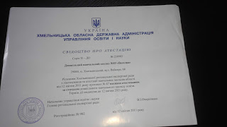](https://3.bp.blogspot.com/-rFtR92T8PGc/W7IatYWMNlI/AAAAAAAABSw/ifc-e0dYjTE5kkSUWPT7zflYLl0JCIdkACLcBGAs/s1600/20180913132358.jpg)